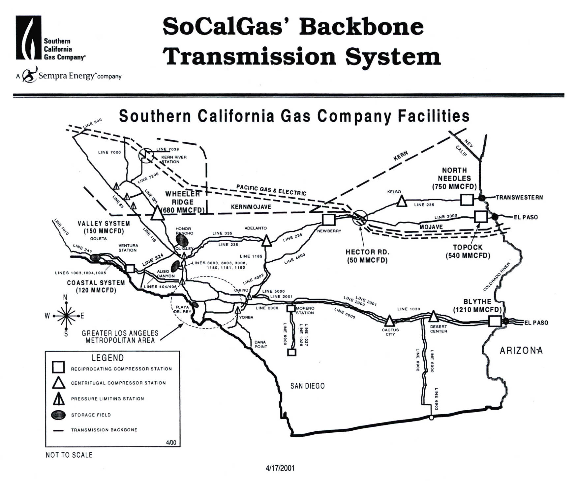

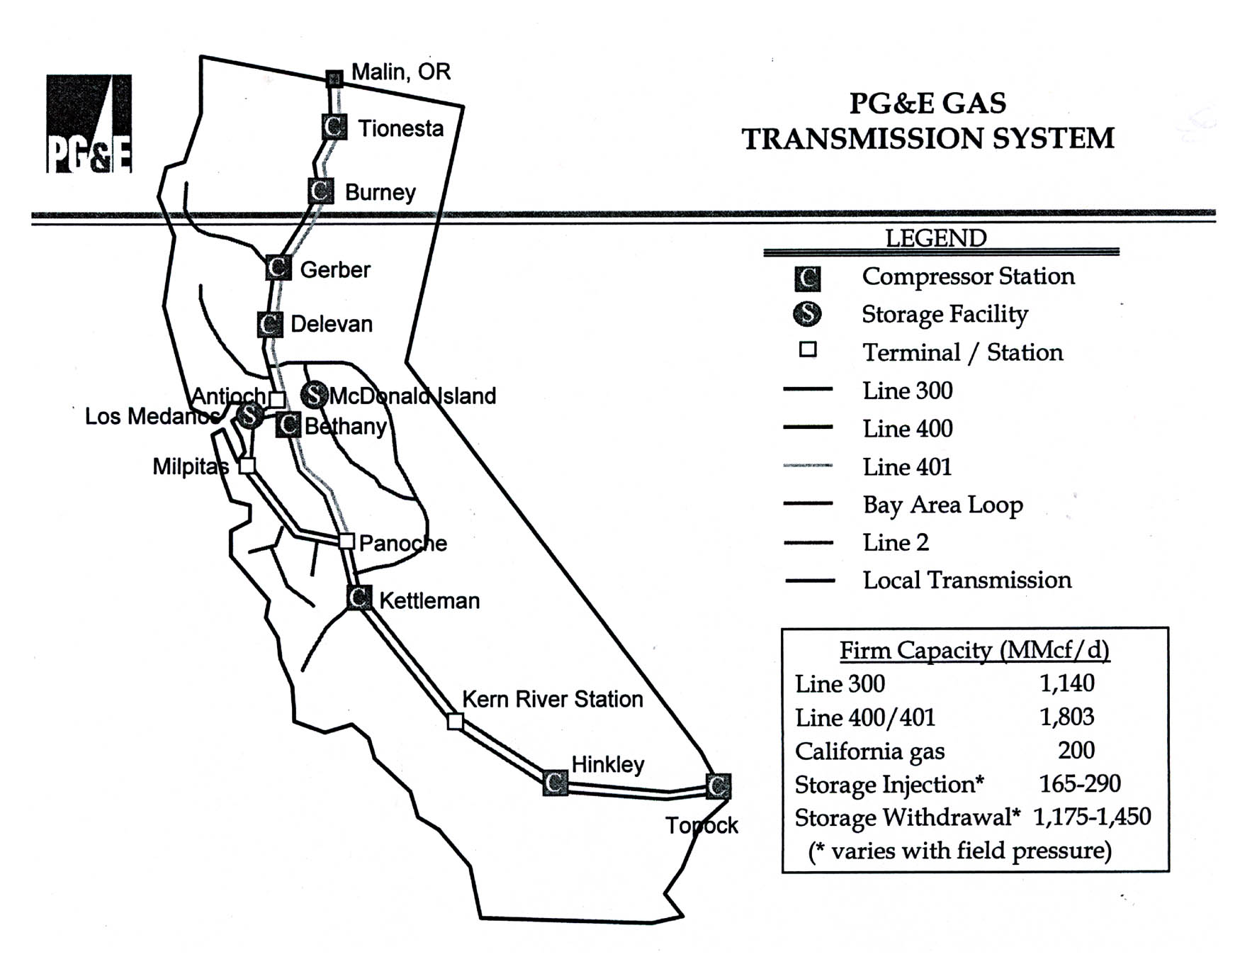

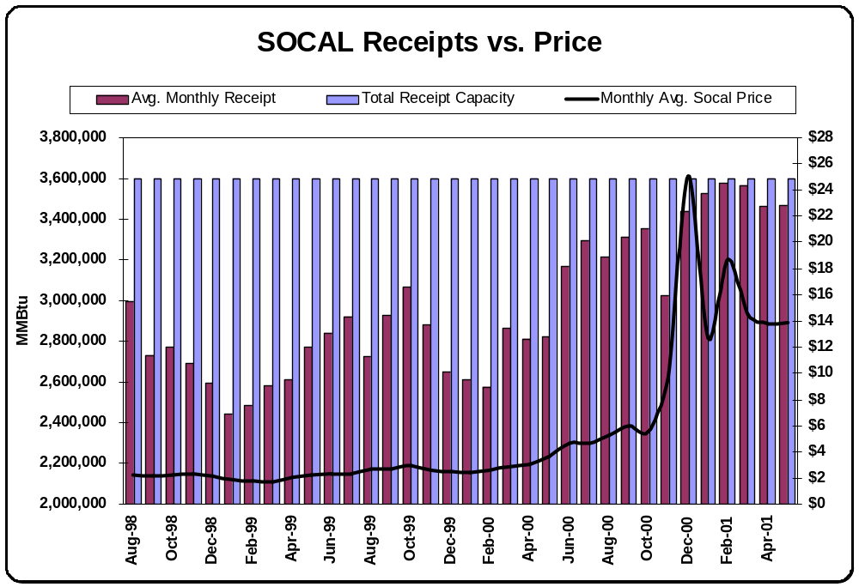
- Prior to Winter 2000-2001, while prices were relatively low, receipts into SoCal Gas for injection purposes were not maximized.

- As prices increased during Winter 2000-2001, receipts into SoCal Gas also increased.

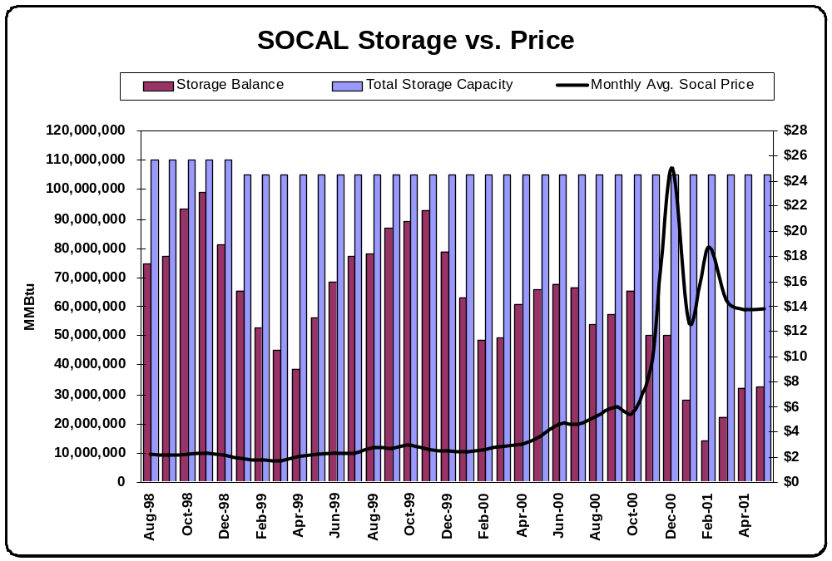

- Storage levels in SoCal Gas’ storage system were not maximized during Q1 and Q2 2000 as prices increased modestly over previous levels.

- The resulting historically low storage inventory levels in October 2000 led to storage deficiencies and subsequent higher natural gas prices during Winter 2000-2001.

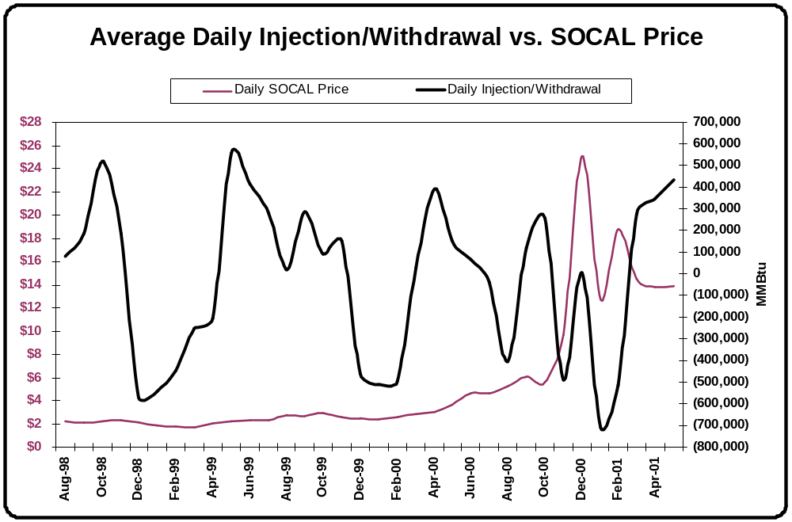

- Historically large withdrawals from SoCal Gas storage during November 2000 and Q1 2001 resulted in higher prices.

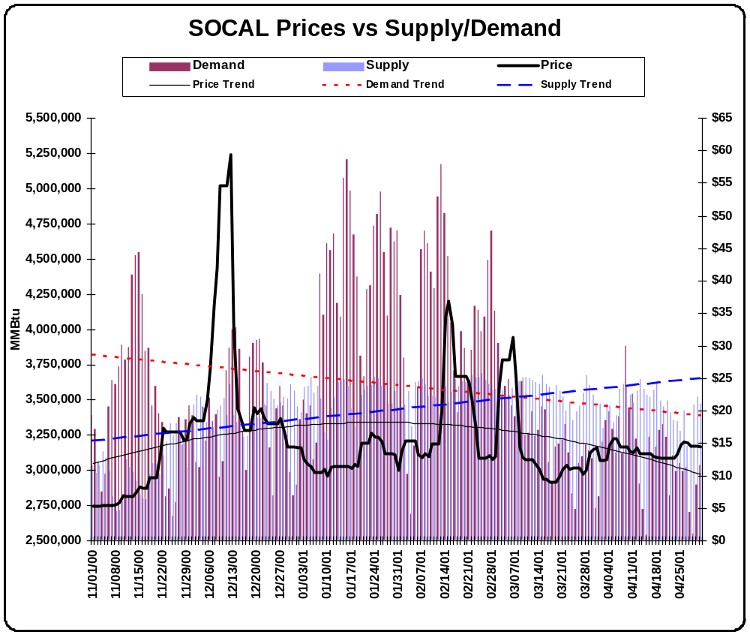

- Graph shows that demand on the SoCal Gas system has decreased over the last six months while receipts into the system have increased.

- A decreasing price trend with less price spikes has occurred over the past two months subsequent to the demand and supply trend lines crossing.

